Amazon Fine Food Reviews Dataset
Task 2 & Task 3 — Analytical Questions, Data-Quality Risks, and Hypothesis Plan
Dataset: Reviews.csv | Purpose: guide exploratory analysis and statistical validation.

A. Meaningful questions to ask of the data
- What is the distribution of ratings (Score 1–5), and are positive ratings more common than low ratings?
- How has the number of reviews changed over time? Are there years or months with unusually high or low review volume?
- Which products receive the most reviews, and how do review volume and average rating differ across products?
- Do reviews with helpfulness votes have a different rating distribution from reviews with no helpfulness votes?
- Do 1-star reviews tend to be longer or shorter than 5-star reviews?
- Are a small number of users responsible for a large share of reviews?
- How much missing information exists in ProfileName and Summary, and could it affect particular analyses?
- Are there duplicate records or repeated review keys that could inflate counts?
- Are helpfulness counts logically consistent, and what should be done when the denominator is zero?
- Are there outlier review lengths, unusual timestamps, or unexpected rating values that need investigation?

B. Potential data issues and risks
Missing values: ProfileName and Summary may be missing. Preserve missing values unless a justified imputation method exists; text analysis should check missing/blank review text.
Duplicate records: Check duplicate Id values, fully identical rows, and repeated combinations of ProductId, UserId, Time, and Text. Repeated keys are candidates for review, not automatic proof of duplication.
Invalid ratings: Score should be within 1–5. Any out-of-range values should be investigated against the source.
Helpfulness logic: HelpfulnessNumerator should not exceed HelpfulnessDenominator; negative counts are invalid. A denominator of zero means a helpfulness ratio is undefined, not zero.
Timestamp interpretation: Time is a Unix timestamp. Convert it consistently and state the timezone; the script uses UTC.
Data types: IDs are identifiers, not numeric measurements. Score and helpfulness counts are numeric; Summary and Text are text fields.
Skew and outliers: Review volume may be concentrated in a small set of products or users. Review lengths may be highly skewed and contain extreme values.
Sampling and bias: The dataset is a collected review dataset, not necessarily a random sample of all customers or all Amazon reviews. Avoid population-wide claims.
Ordinal ratings: Score is an ordered category. Mean-based tests can be informative but rely on treating rating steps as approximately equal; use non-parametric tests as a robustness check.
Large sample size: With hundreds of thousands of rows, tiny differences can become statistically significant. Report effect sizes and practical importance, not p-values alone.

C. Hypotheses and validation plan
H1 - Rating benchmark. H0: the mean numeric score is 3.0. H1: the mean score differs from 3.0. Use a one-sample t-test and report the mean, p-value, and standardized effect size. Note that ratings are ordinal.
H2 - Helpfulness-vote groups. H0: rating distributions are the same for reviews with at least one helpfulness vote and reviews with a zero denominator. H1: distributions differ. Use a two-sided Mann–Whitney U test; describe this as association, not causation.
H3 - Review length by extreme rating. H0: review-text-length distributions are the same for 1-star and 5-star reviews. H1: they differ. Use a two-sided Mann–Whitney U test and compare medians. The script uses a reproducible random sample for text-length analysis if needed.

D. Visualizations to include
- Bar chart: count and rating of reviews by Score.
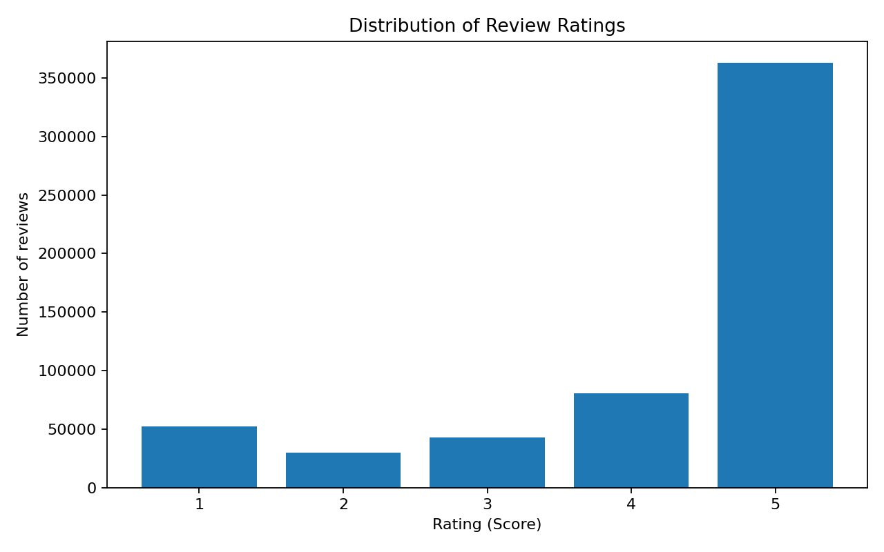
- Line chart: review volume by year (and monthly trend table for finer inspection).
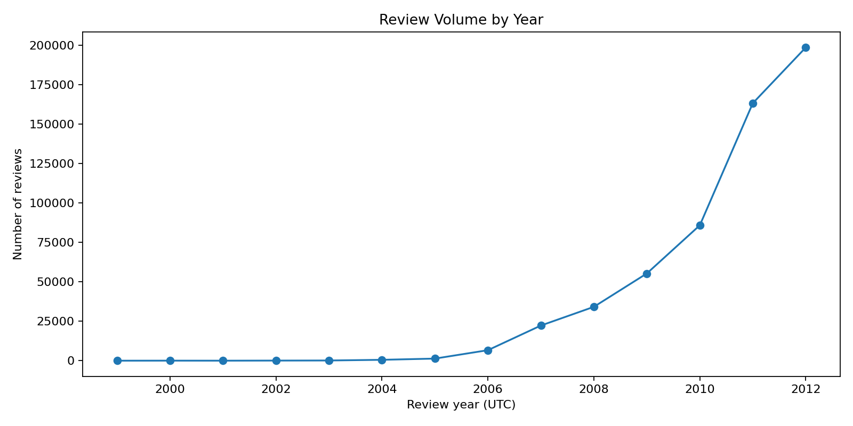
- Histogram: review-text length, with the displayed range capped to make the distribution readable.
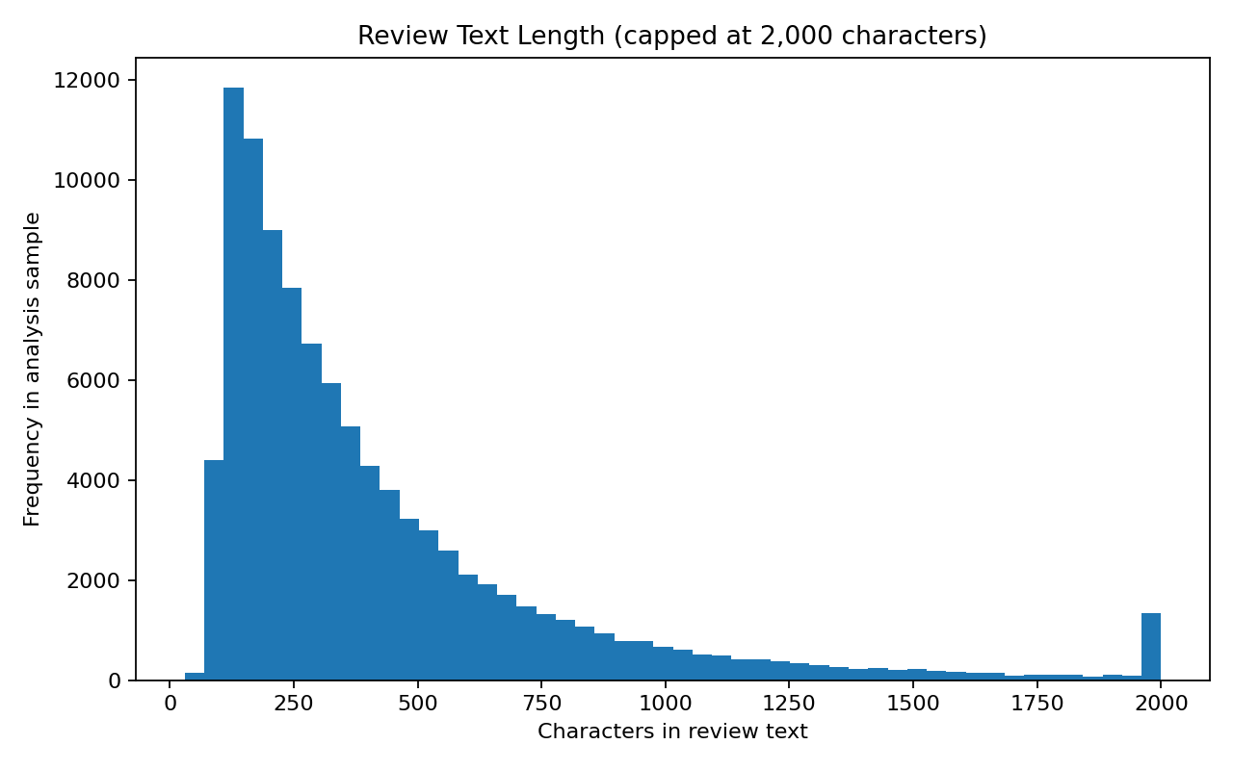
- Horizontal bar chart: top 10 products by review count.
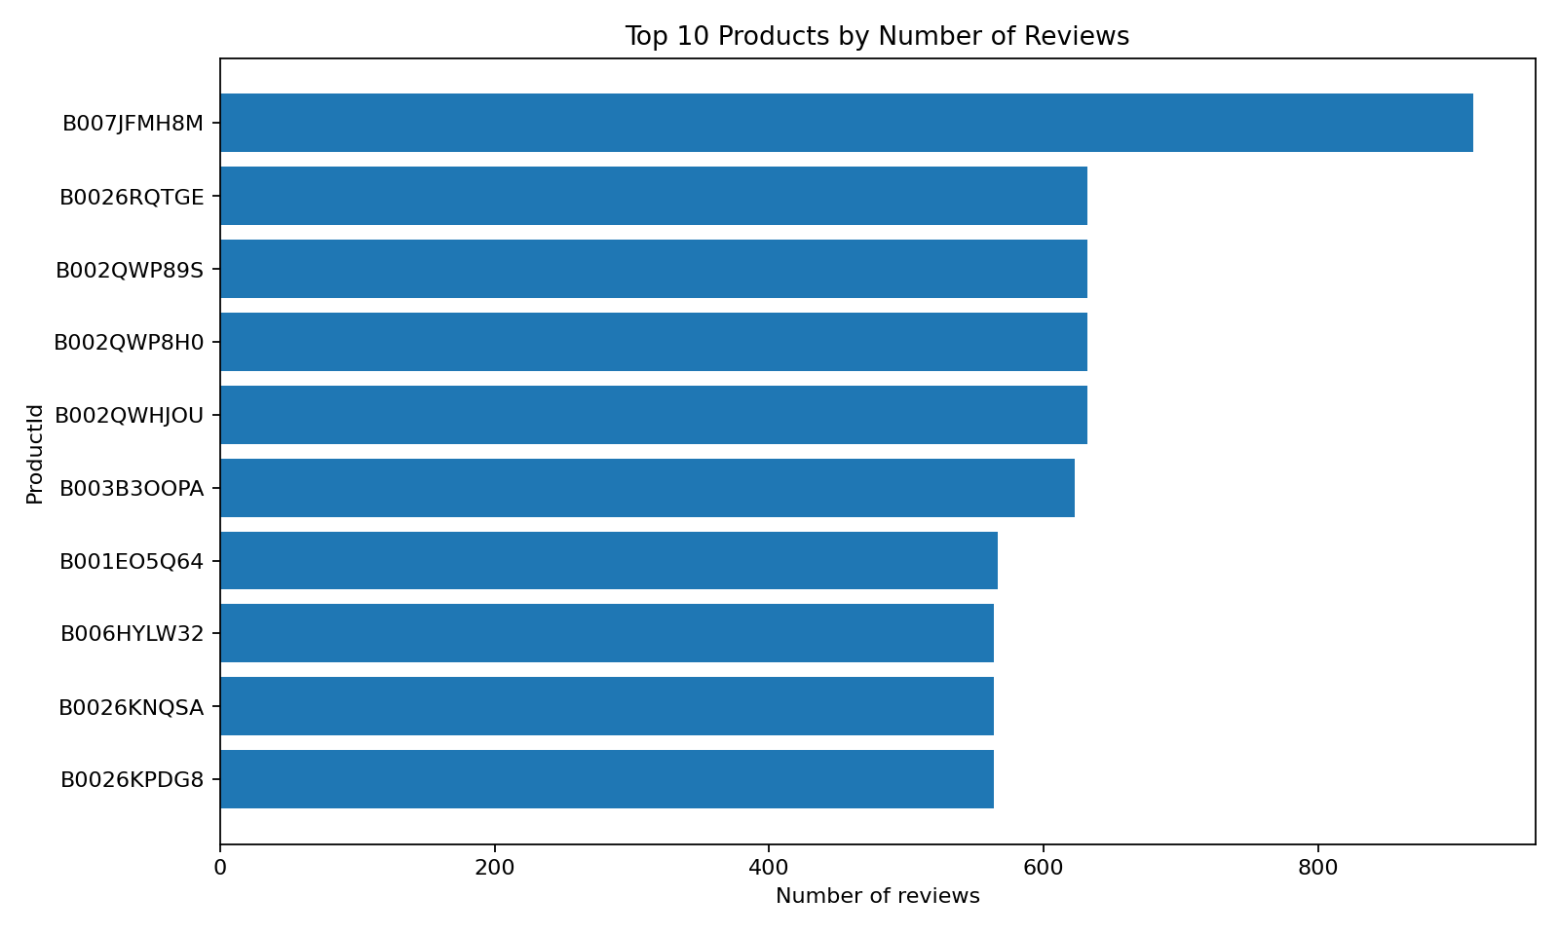
- Boxplot: review-text length for 1-star versus 5-star reviews.
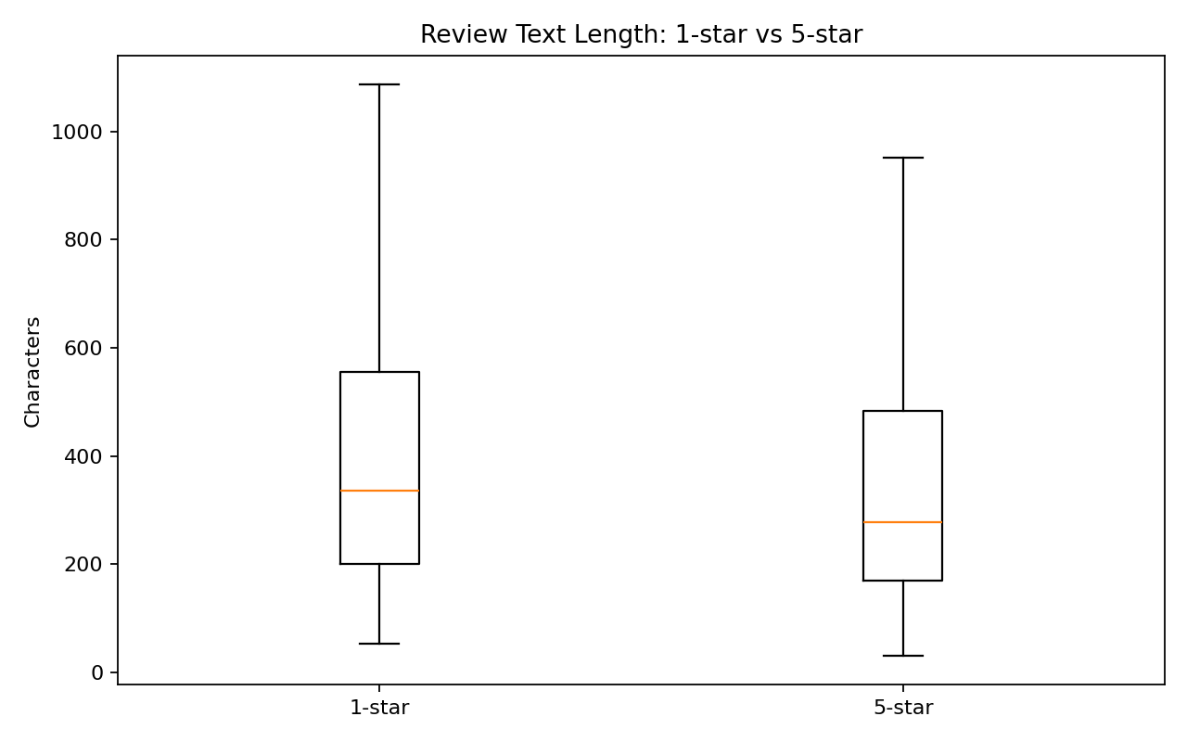

E. Interpretation of the results.
- Use p < 0.05 as a conventional threshold, but report the exact p-value where possible and pair it with an effect size.
- Do not claim that helpfulness votes cause a rating difference; the analysis is observational.
- Check whether conclusions change when repeated keys or invalid records are excluded in a sensitivity analysis.
- Document every exclusion and preserve an untouched copy of the original dataset.
- Treat unusual records as flags for investigation, not errors, until evidence supports correction or removal.

F. Running the Python analysis
Install dependencies if needed:
pip install pandas numpy matplotlib scipy
Place reviewstask2task3analysis.py in the same folder as Reviews.csv, then run:
python reviewstask2task3analysis.py Or specify paths explicitly:
The script creates a text report, CSV tables, hypothesis-test results, and PNG charts. It does not overwrite the source CSV and does not automatically delete flagged rows.

